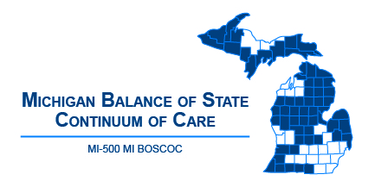 | Michigan Balance of State Continuum of Care  Governance Council Meeting  January 10, 2019  10:00 am - 12:00 p.m.  Webinar:  https://attendee.gotowebinar.com/register/129280967506122753
Meeting Agenda
10:00-10:05 | Welcome and Introduction
10:05-10:10 | Review/Approve Agenda (action item)
10:10-10:15 | Review/Approve December 13 Meeting Minutes (action item)
10:15-10:40  (25 minute  presentation and Q & A) | - Putting Street Outreach to Work in Your Community – Ryan Hannon
Committee Updates
10:40-10:50 | Coordinated Entry – Ashley Halladay-Schmandt
10:50-11:00 | Finance – Denise Cornelius
11:00-11:10 | Performance and Outcomes – Alice Stone
11:10-11:20 | Membership and Nominating – Christa Jerome
11:20-11:30 | Contractual Oversight – Denise Cornelius
11:30-11:40 | HUD CoC Application and Evaluation – Lori Pieri
11:40-11:50 | Vulnerable Populations – TBD  - 100 Day Challenge Opportunity – Christina Soulard
11:50-11:55 | Coordinator Update
11:55-12:00 | Public Comment/Announcements
Adjourn
Next MI BOSCOC Governance Council Meeting
Thursday, February 14
10am to 12pm

