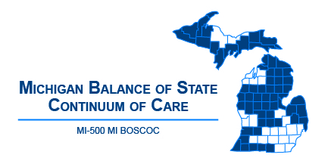 | Michigan Balance of State Continuum of Care  Governance Council Meeting  September 13, 2018  10:00 am - 12:00 p.m.  Webinar:  https://attendee.gotowebinar.com/register/129280967506122753
Meeting Agenda
10:00-10:05 | Welcome and Introduction
10:05-10:10 | Review/Approve Agenda (action item)
10:10-10:15 | Review/Approve August 9 Meeting Minutes (action item)
10:15-10:50  (35 minute  presentation and Q & A) | - FY17 HUD CoC Round Debrief and FY18 HUD CoC SWOT Analysis – Christina Soulard, Coordinator
Committee Updates
10:50-10:55 | Coordinated Entry – Ashley Halladay-Schmandt
10:55-11:05 | Finance – Denise Cornelius  - Review/Approve FY17 Planning Grant Budget (action item)  - Review/Approve proposed FY18 Planning Grant Budget (action item)
11:05-11:15 | HMIS and Performance and Outcomes – Alice Stone
11:15-11:25 | Membership and Ad-Hoc: Nominations – Christa Jerome  - Solicit nominations for Vice Chair and Treasurer (Election at October 17 meeting)
11:3-11:35 | Monitoring – Denise Cornelius
11:35-11:45 | Project Evaluation – Lori Pieri  - Review/Approve FY18 HUD CoC Project Ranking – Budget (action item)
11:45-11:55 | Vulnerable Populations – Bill Jessup
11:55-12:00 | Public Comment/Announcements
Adjourn
Next MI BOSCOC Governance Council Meeting
In-Person: Wednesday, October 17
9am to 11:30am
Ann Arbor Hotel Marriott Ypsilanti at Eagle Crest
1275 S Huron St, Ypsilanti, MI

