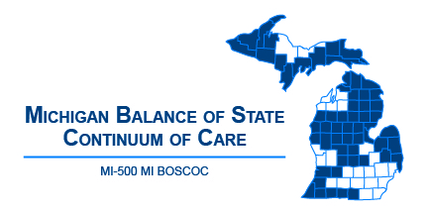 | Michigan Balance of State Continuum of Care  Governance Council Meeting  October 17, 2018  9:00 a.m. to 11:30 a.m.
Meeting Agenda
9:00-9:15 | Arrival / Beverages and Snacks / Map Activity
9:15-9:20 | Welcome
9:20-9:35 | Building a Firm Foundation
9:35-9:40 | Reflections on Map Activity
9:45-10:30 | Coordinated Entry  - OrgCode Update  - Coordinated Entry Committee Presentation  - Small Group Breakout Discussion
10 Minute Break
Please complete member surveys and Conflict of Interest forms - return to Christina
10:40-11:00 | Governance Charter Review
11:00-11:20 | GC Big Picture Role
11:20-11:30 | Reflections / Wrap Up
Adjourn
Next MI BOSCOC Governance Council Meeting
Thursday, November 8, 2018
10-12pm

Executive Committee Members:
Tina Allen – Chair
Lori Pieri – Vice Chair
Christa Jerome – Secretary
Denise Cornelius – Treasurer
Eric Hufnagel – Past Chair

BoS CoC Committees and Chairs:
Coordinated Entry – Ashley Halladay-Schmandt
Finance – Denise Cornelius
Membership – Christa Jerome
Monitoring – Denise Cornelius
Nominations – Christa Jerome
Performance and Outcomes – Alice Stone
Project Evaluation – Lori Pieri
Vulnerable Populations – Bill Jessup

Beverages and Food Provided by
Thank you!

